

DECLARATION OF PERFORMANCE
No. GM250-memb
According to Annex III of the Regulation (EU) No. 305/2011

Name of the product
Plastomeric (APP) Bituminous Waterproofing Membranes

- Unique identification code of the product-type:
ESHAGUM SP

- Type, batch or serial number or any other element allowing identification of the
construction product as required pursuant to Article 11 (4):
Batch number: see packaging of the product

- Intended use or uses of the construction product, in accordance with the
applicable harmonized technical specification, as foreseen by the manufacturer:
Waterproofing of flat and inclined roofs, under tile waterproofing,
waterproofing of basements, underground structures,
bridges and general construction elements

- Name, registered trade name or registered trade mark and contact address of the
manufacturer as required pursuant to Article 11 (5):
ALFA ALFA ENERGY SA
Paralia Aspropyrgou Attikis
19300 Aspropyrgos, Athens - Greece

- Where applicable, name and contact address of the authorized representative
whose mandate covers the tasks specified in Article 12 (2):
Not relevant

- System or systems of assessment and verification of constancy of performance of
the construction product as set out in Annex V:
System 2+

- In case of the declaration of performance concerning a construction product
covered by a harmonized standard:
EN 14695:2010 System 2+
The notified body
B.A.S.-Institute of Mechanics-Mechatrol, Sofia
Performed the initial inspection of the manufacturing plant and of the
factory production control and the continuous surveillance, assessment and
evaluation of factory production control under system 2+ and issued:
1938-CPR-0425
Certificate of conformity of the factory production control

- In case of the declaration of performance concerning a construction product for which a European Technical Assessment has been issued:
Not relevant

- Declared performance

Technical Characteristics | T* | Performance | Unit | Test  Specification
Visible defects |  | No defects | - | EN 1850-1
Length | ± 0,02 | 8 or 10 | m | EN 1848-1
Width |  | 1 | m | EN 1848-1
Straightness |  | Pass | mm/10 m | EN 1848-1
Mass per unit area | ≥ | 5,5 | kg/m² | EN 1849-1
Thickness | ≥ | 4,5 | mm | EN 1849-1
Tensile strength Long. / Trans. | ≥ | 900 / 750 | N/50mm | EN 12311-1
Elongation Long. / Trans. | ≥ | 40 / 45 | % | EN 12311-1
Shear Strength | ≥ | 0,22 | N/mm² | EN 13653
Water absorption | ≤ | 1.5 | % | ΕΝ 14223
Flexibility at low temperature | ≤ | -10 | °C | EN 1109
Flow resistance at elevated temperature | ≥ | 120 | °C | ЕN 1110
Dimensional stability at elevated temperature |  | -0,4 / +0,3 L/T | % | ЕN 1107-1
Crack Bridging ability |  | Pass at -10 ºC | ºC | EN 14224
Compatibility by Heat Conditioning (91 d at 50±2ºC) | ≥ | 87 | % | EN 14691  EN13653
Thermal ageing behaviour -Flexibility at low temperature -Flow resistance at elevated temperature |  | ≤ -5 ≥ 100 | °C | EN 1296 ( EN 1109 ) ( EN 1110 )
Bond strength | > | 0,4 | N/mm² | EN 13596
Resistance to compaction of an asphalt layer |  | Pass by watertightness at 100 KPa for 24h | - | EN 14692 Method 2  EN 1928
Watertightness |  | Pass | - | EN 14694
Dangerous substances (asbestos or coal tar) |  | Does Not Contain | - | EN 14695,  § 4.4
Τ*: Tolerance

- The performance of the product identified in points 1 and 2 is in conformity with the declared performance in point 9.
This declaration of performance is issued under the sole responsibility of the manufacturer identified in point 4.

Signed for and on behalf of the manufacturer by:
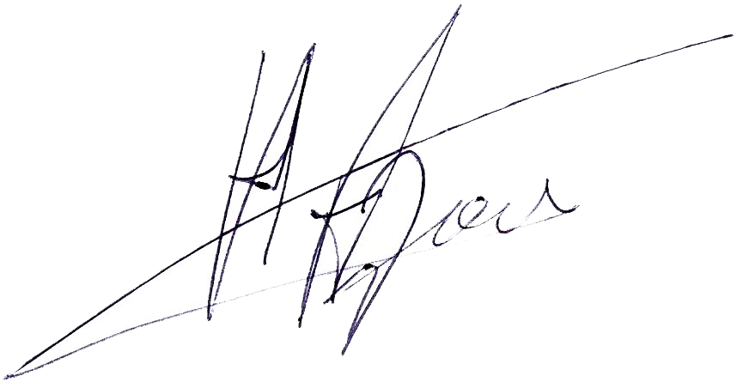

Elias Aloupis,
Chemical Engineer
Quality Control Manager Aspropyrgos, 10/01/2022

